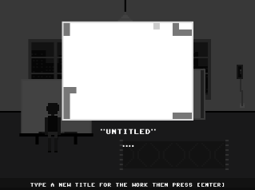
I’m amazed how hard it is to title the work. I find myself looking at it and seriously trying to find a title that fits the image. Well done Pippin Barr.
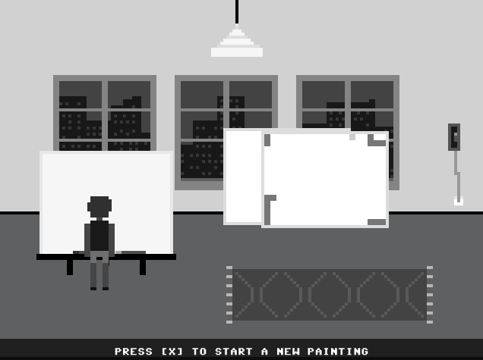
Love the painting stacked against the wall. My favourite pic so far.
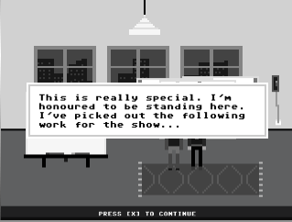
That’s it. Fuck sculpture. I’m a painter.
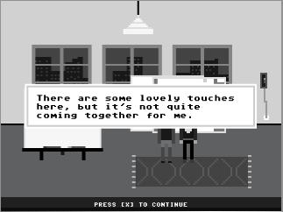
Back-slider.
This feels wrong. She picked my work for the show and then told me it needed more work now “it’s not quite coming together for me’ I feel cheated. One of the scripts may be in the wrong pile.
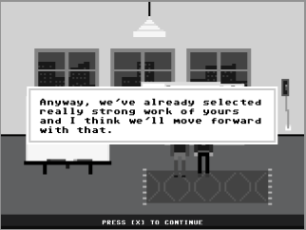
Now she’s telling me she has already selected strong work of mine. Oh… hang on… I’m in the gallery. Must have been a glitch there somewhere.
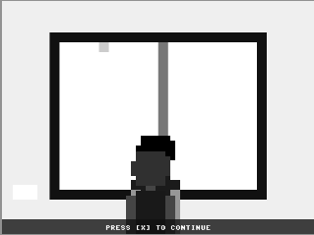
OK, went to look at the label and nothing came up.

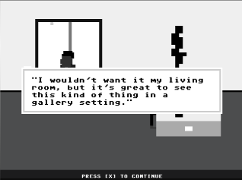
Then this popped up which I guess is from one of the morons looking at my masterpiece.

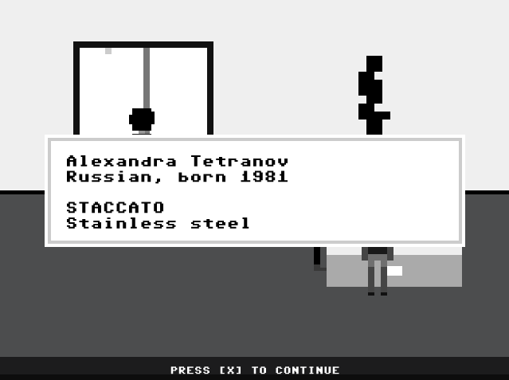
Initially thought this was one of my works from the previous turn… but nice to see Alex in the show.
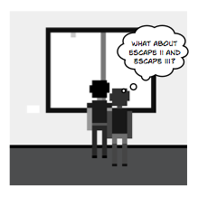
She only selected one of my paintings! I can’t believe it… and the weakest one at that.

I’m getting the hang of it now so forget that bit about not being able to see all the paintings (a matter of using the side arrow, duh).
Will try to think of more responses now I get the game. Think it is one of your best particularly the first bit when you are trying to get into the show. Feels horribly real.
Will take a break and then onto performance art… my speciality.

